A picnic of promise
30 Sept 2015
http://www.alicespringsnews.com.au/2015/09/30/a-picnic-of-promise/

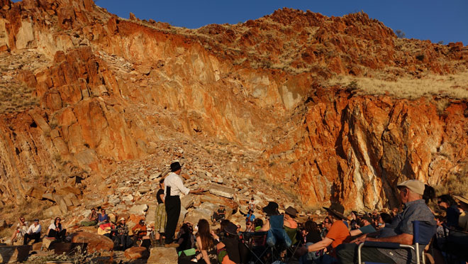
Gathered at the quarried Ilparpa site; Craig San Roque begins the story-telling. This and photos below by FIONA WALSH except where specified.

By KIERAN FINNANE

It is as though a mouth in the rockface has been prised open and stomach contents disgorged, teeth too. This is the deepest of the scars left by the quarrying of stone from the range rising along the southern side of Ilparpa Valley. The disgorgement settles on a flattened turnaround for trucks and machinery, high above the valley; a second smaller turnaround has been carved out below. The road leading up to it has eroded into a deep gully; just a goat track at the side holds on, buttressed by buffel grass and rock. Up this track we go, for a picnic of promise.

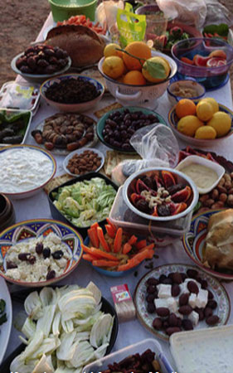
There is food yes, tables laden with crusty brown loaves, oil for dipping, olives, black and green, luscious yogurt, Mediterranean vegetables and fruits. No wine. Our town has an uneasy relationship with wine. It is banned in public places (in many private places too). Despite unlikely detection, we abstain.

Before we eat we hear the first part of a story of origins, an ancestral creation story for this food culture we so love. ‘We’, what ‘we’ is this? In a place like Alice Springs this is never a simple category. Looking around, at the crowd of loosely connected people, gathered by word of mouth, I can say it is a multi-cultural ‘we’ of recent arrivals whose history here might go back decades, even a generation or two, not longer and for some much shorter. Our ‘we’ also includes a few visitors, family and friends who have come especially and soon will go again.

The invitation to gather has filtered out from Craig San Roque, author of The Long Weekend in Alice Springs (his original essay later adapted and drawn by Joshua Santospirito as a graphic novel), and a troupe of friends – musicians, artists, performers. They will work with him to tell the version he has penned of an old story. Bringing their various talents to it they will perform it on the stage of the abandoned quarry’s higher turnaround.

We know from listening to Aboriginal people how intrinsically story and place are linked for them. When the connection is broken, something in them is broken. We know from The Long Weekend San Roque’s counsel that we likewise should “mind our own stories”. They are a critical part of our psychological inheritance. They help us think about who we are, how we came to be here, at this place and this time, and about how to act. “The Kore story / Persephone’s Dog” is one of those.
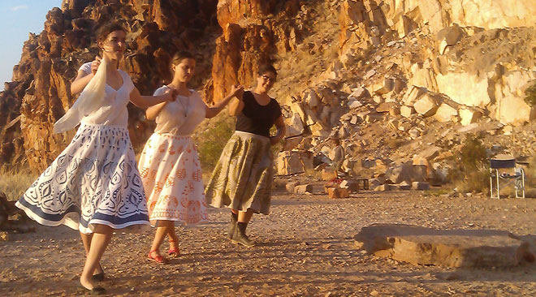
Kore dancers, from left, Sia Cox, Miriam Pickard and Anna Flouris. Cox, of Greek descent and an artist, created the skirts, inspired by the designs of her great-grandmother, Cleopatra Katsoolis. Flouris, of Greek-Cypriot descent, was cultural custodian of the story. She offered a lesson in the pronunciation of the greek names and parts of the narrative in the Greek language. Photo by Erwin Chlanda.

For most of us picnickers, our ancestral places are found in old Europe and many of us experience at some level a sense of loss in our severance with these roots. This is acknowledged beautifully at the start of the performance by Genevieve O’Loughlin in her song, ‘The Emigrant’ (‘My long lost country I cry for you’). It tells a story of the Irish diaspora, but the themes are shared broadly by many migrant peoples. With physical displacement goes a cultural one – language, music, dance, story, connection with country all attenuate, even disappear. San Roque urges us to be mindful of the loss, to be mindful too of the imaginative possibilities of retrieval and to make the connections between past and present.

What we are about to hear begins at Delphi in ancient Greece, the navel or womb of the world, so the story goes. Two women are travelling …

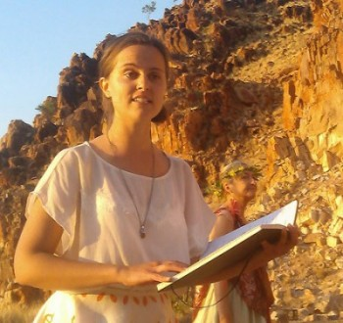
Straightaway an echo sounds with the Aboriginal stories of central Australia, where the creation ancestors travelled across the country, forming it as they went. So it is with Demeter, born from the Mother Rock at Delphi. Where she travels, the land divides, rivers run, mountains rise and plants grow. Daughter Kore follows in her footsteps; eyes grow in her, she learns to see and listen.

Left: Miriam Pickard in the role of Kore; behind her, Penelope McDonald as Demeter. Photo by Erwin Chlanda.

Demeter creates with a loving originary power, body and creation are one. “She rose up, she covered the whole world. The whole world inside her body; in the beginning. The whole sky inside her body. Two eagles flew around her, inside her. One flew to the east, one flew to the west. The two eagles flew right around the body of Demeter. They flew right around inside the skin of the sky; inside the body of the first mother.” In San Roque’s poetic script we hear the echo of Arrernte song, its rhythms and repetitions, its movements. And we look up: off the red cliffs at Ilparpa falcons soar in the updraft. It is as if the country and its creatures are taking part in the drama.

Demeter’s story describes the what and how of the Grecian land: “She marks out a line deep between the mountains. The Shining Mountains she calls them. She makes the line deep. It cuts through her body. She cuts a long cut between her breasts. Water runs always along this cut. Down this line a river will run, she says. It will run to the sea, it runs all the way down. She names it – Pleisto – the best. This is the best of rivers, she says. This river, I love.”

From watching and hearing, Kore begins to think, to explore the why of the way things are and their possibilities for sustaining life, working in with her companion dog. She sees that certain plants grow in certain places; she watches as the dog samples their fruits. She learns what is edible; she thinks about what to do to make the foods kind to the taste. Thus she washes in salt water the bitter ‘berries’ of the first olive tree. Soaking olives in brine: a recipe from the original hearth.

Why care? Why not simply pluck a jar from the supermarket shelves, enjoy the fruit and salt taste, and be done with it? For the beginnings of an answer, stand alongside Demeter and Kore – this mythic pair, Mother Daughter or Mother Maiden (the older and younger form of the one woman), associated with life-sustaining cereal plants, often called Earth or Corn-goddess. (In Roman mythology Demeter was known as Ceres and Kore / Persephone as Proserpina.)

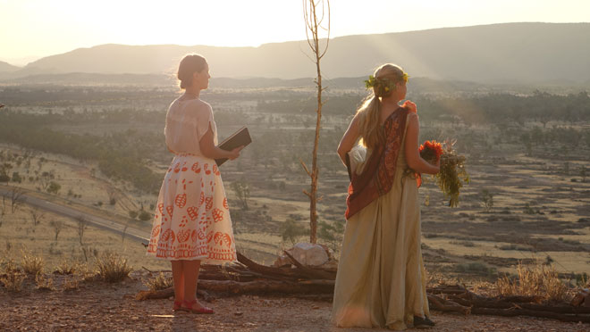

At the edge of the quarry cliff with them we look into the valley. It may be one of the most beautiful in the land, despite all its scars – the marks of a system of land management, if you can call it that. The rubbish dump. The sewage ponds, relying on evaporation in the dry heart of the driest continent on earth. The railway and highway along which the food and most else that we rely on is ferried into town. The pale grass across the valley floor looks soft and yielding in the late golden light, but we know it is buffel, an invasive species that is squeezing out native vegetation and elevating the fire risk to what remains. We can see very little that reflects deep thought and care, very little that will sustain us if, or rather when, times get tough. Yet we call it ‘civilisation’.

The sun sinks into the blue and purple mountains in the west, its last long rays lighting the vivid rockface behind us. We are called to the second part of the story-telling. Kore’s beloved dog samples a poisonous fungus and dies. “Kore cried out for her dog. Her dog did not move. / The wind moved, the sea moved, but the dog did not move. / What is this, said Kore, I have never seen this before. / She held her dog in her arms; she walked into the rocks.” And so Kore comes up against the ending that is part of all living things. In her grief she goes with him into the underworld.

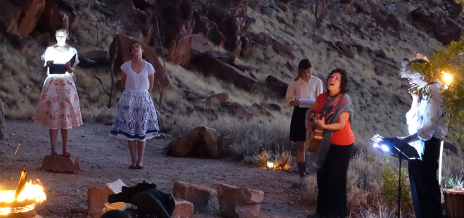
Ruth Apelt gives a passionate rendering of ‘Dido’s Lament’ (‘When I am laid to earth’) by Henry Purcell, in dialogue with the grieving Kore.

In the fiery underworld scenes we see the spectre of all we have to lose, wrought by the poetry, amplified by the flames and black smoke; we see the destructive power of the worst of ourselves set loose upon the world. Yet there is something else going on at the same time: in Kore’s life with Hades whom she loves (we encounter him only as a resonant voice), she discovers the roots of things, the seedbed, and thus the continuing of things. There are different versions of the classical story: in some Hades is said to abduct and rape Kore; in this adaptation San Roque has chosen to show their travels underground as a sensual, thought-provoking exploration of “this world inside the world”, out of which Kore, renamed by Hades as Persephone, will emerge as “the one to teach the people”. She will teach them how things are destroyed and made again – the foundation of European agricultural practice. She carries that knowledge in her body and in her mind, intimately linked to the memory of her mother. It is the taste of pomegranate first given to her by Demeter that calls Persephone back from the underworld.

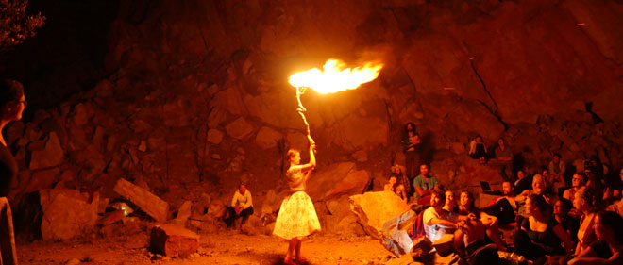

“She can hear the singing of women. She comes up. Kore comes up. / She comes up through the crack in the rock, she is a like a fig tree in the morning. / The birds gather, wings flicker; birds shimmer in the leaves of the fig tree. // Coming up by the rock hole in the morning, Persephone, water shining along the roots, water shining on the leaves of the tree, birds flickering. She comes up. // I can feel on my tongue, the taste of my mother, I am coming out, she cried. I am coming out …”

In the West we have moved a long way from minding the simplest of connections. We plug the gaps with technological know-how but are starting to see how it is bringing the earth undone. The gift of this picnic with Persephone was to put us back in touch with the beginnings of our European kind’s understanding of the earth, its what and how and why, and the way we can work with it. To follow that thread back across the millennia, to dwell for a while in that early time, to heed the fundamental wisdoms of our ancestral culture, is a deeply nourishing experience.

Significantly the ancients locate our origins in the generative body and minds of women, the original Mother Daughter or Mother Maiden pair. As a woman I felt I had waited a long time, all my life really, to experience such an honouring of Mother Daughter in the world – the World becoming, Mother Daughter becoming, intertwined, intuitive, intelligent and loving.

Not bad qualities to carry into our contemporary lives and times, to put towards the repair of so much ruin.

San Roque tells us that Perspehone’s story was performed at Eleusis in Greece for two thousand years, its participants sworn to secrecy on pain of death. It was banned and the site destroyed in 396 AD by “fervent champions of a new religion”.

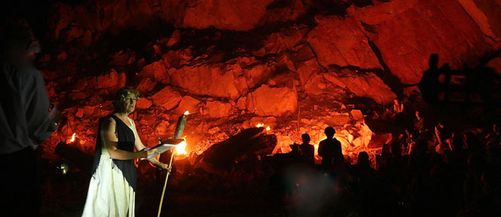

“I think some of her story went underground,” he says, “and re-appeared in icons that feature a mother in grief at the loss of her son. And his return. As the woman returned from the dark in the form of Persephone.”

Today Eleusis is a broken site, “a memorial to loss”, like the Ilparpa quarry: “I have seen simple and broken places like this across the countries where old ceremonies were performed and lost,” says San Roque. “And artillery shells and madmen ruined their grace. Because of that ruin I wrote this story.”

Here, in the central Arrernte homeland, we too can see the sites where old ceremonies were performed and lost, sites that are scarred, hemmed in, sometimes ruined. For those of European descent perhaps a new awareness of our own long lost countries and classical cultures can put us in the way of better seeing this history and hearing Arrernte stories: not the little husks of stories from interpretive panels and brochures; the stories as told by living Arrernte people and as they deeply imagine them in paintings, song and dance; stories still embodied in the country.

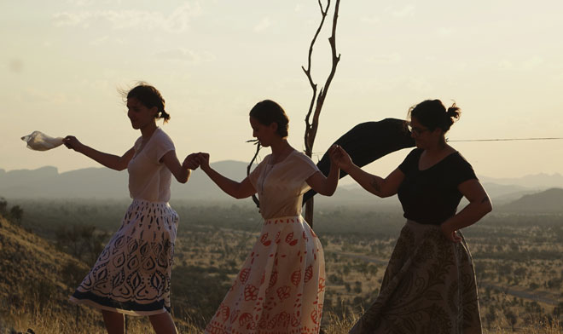

“The lines Demeter draws are the lines we should not change. The places Demeter has placed here for a reason. Those places hold the world in balance. / The cave, the granite, the tree, the river and the flow of clear water. She says , ‘I love this place’, and so, we love this place.”

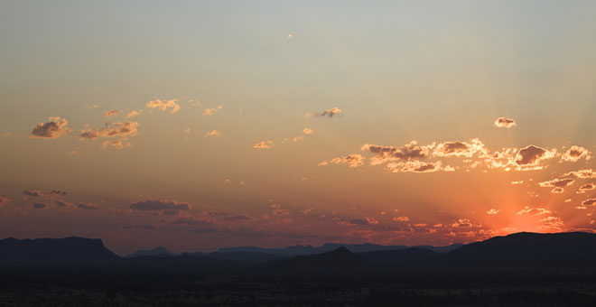

FURTHER READING:

The original poetic script by Craig San Roque, ‘The Kore Story / Perspehone’s Dog’, can be found in the book Ancient Greece, Modern Psyche: Evolving Archetypes, edited by VB Rutter and T Singer, Routledge, 2015, available at Red Kangaroo Books.

For the story behind the Kore skirts, see Against the tide: the soft figuration of Sia Cox

